**AZURE ASSIGNMENT**

**VISUALIZATION**

**SCATTER**

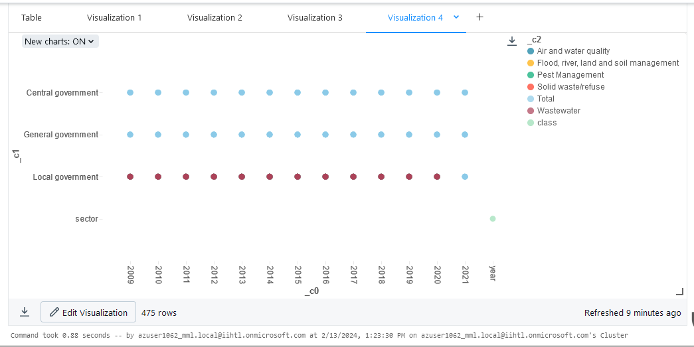

**PIE**

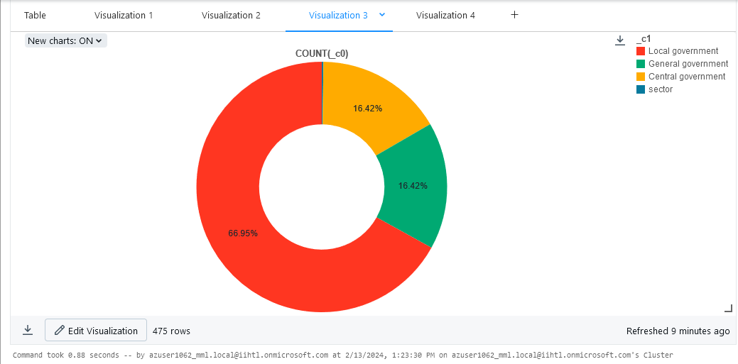

**HISTOGRAM**

